The College of Dental Surgeons of Hong Kong | 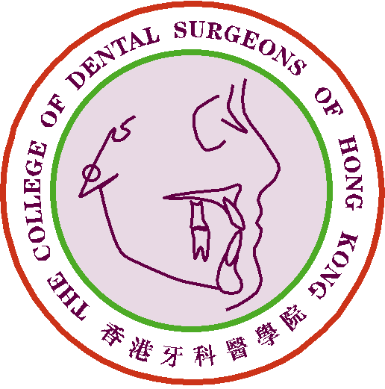

Claim Form for CME/CPD Programme

Personal Data |  | Date of Submission :
Name of Applicant : |  | Phone No.:
Email address: |  | Fax No.:

Please ☑ one only :
1) Fellow or Specialist |  |  | 2) MGD Holder |  |  | 3) Specialist Trainee

Postgraduate Courses
Name of Institute:
Name of Course(s):
Title of Qualification on completion (if applicable):
Starting from (month/year): |  |  |  |  |  |  |  |  | Completing on (month/year):
Full time: |  |  |  |  |  | Part time:
No. of CME point(s) claimed:
Remarks: | Qualification acquired/awarded after completion of the course must be registrable with the Dental Council of Hong Kong
 |  |  |  | Supporting documents attached : |  |  |  |  |  |  |  |  | page(s)

For Official Use Only | Points Awarded:
For Official Use Only | Total | CME point(s)

- The CME Subcommittee has the rights to evaluate, approve, review and revise the CME point(s) for the above activity/activities.
- Please send this form and other supporting documents by e-mail: cme_cpd@cdshk.org for processing after completion.

(Please make photocopies of these forms whenever applicable or download from
CDSHK website under “Forms Download”: http://www.cdshk.org/Forms/index.htm)

